Written Lab 8: Lab on Routers

Key Networking Terms:

1. Longest match rule
   1. The rule for routing tables to look for the longest match for an IP before routing a packet. This allows administrators to make detailed routing directions for each router.
2. Process Switching
   1. A forwarding technique that looks through the entire forwarding table before sending a packet. It is very inefficient and outdated.
3. Fast Switching
   1. Forwarding technique where the exit interface and layer 2 header are cached of recent destinations; this speeds-up the process of finding an address to forward to.
4. Cisco Express Forwarding
   1. A forwarding technique developed by Cisco. The technique involves using multiple forwarding table caches and is updated when the network changed, not just when a packet is sent through. The result is a router than prevents rewriting at the time of sending and resolves future error before they occur.
5. Static Routing
   1. A routing method that requires an administrator to manually enter where traffic on each router will be directed. The method is great for smaller and unchanging (static) networks, but is a nightmare for larger and mutating/growing networks.

Procedures:

1. Lab Simulation #4
   1. Dynamic Routing
   2. Starting configuration:

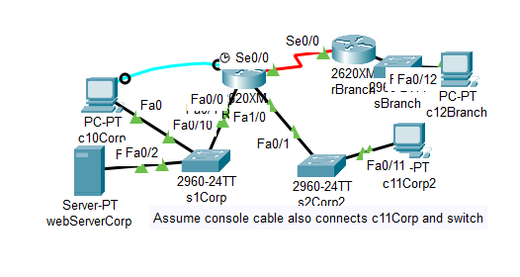

* 1. Lab Procedures:
     1. Make sure c10 and c12 can only ping themselves and not each other
     2. Set up rCorp with the networks

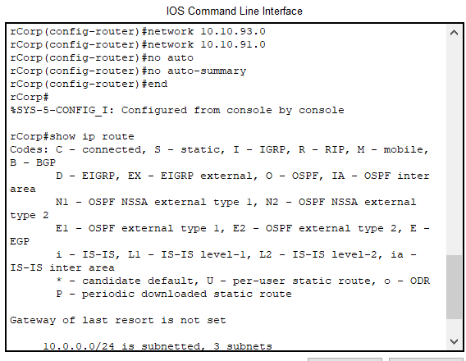

* + 1. Set up rbranch with the networks

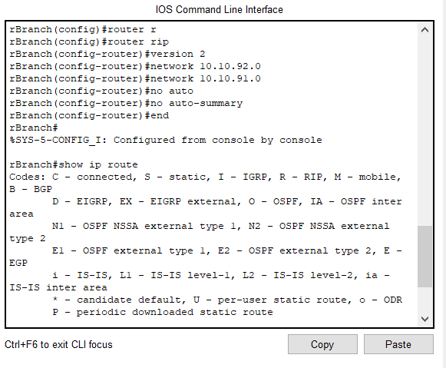

* + 1. Let RIP updates occur, then try pinging the two again

1. Lab Simulation #5
   1. DHCP Dynamic Routing
   2. Starting configuration:

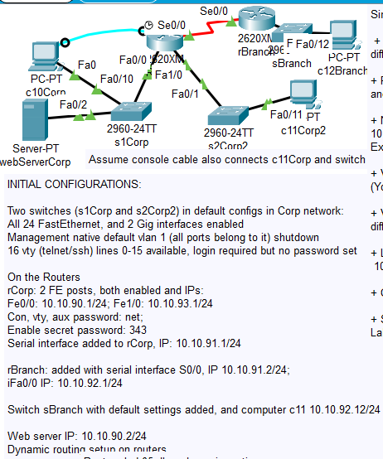

* 1. Lab Procedures
     1. Make sure the different networks can ping, remove the Ips at c10, c11, and c12, then set up new IPs by a dhcp server

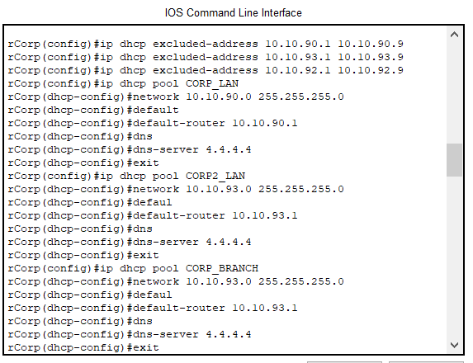

* + 1. Verify new ping

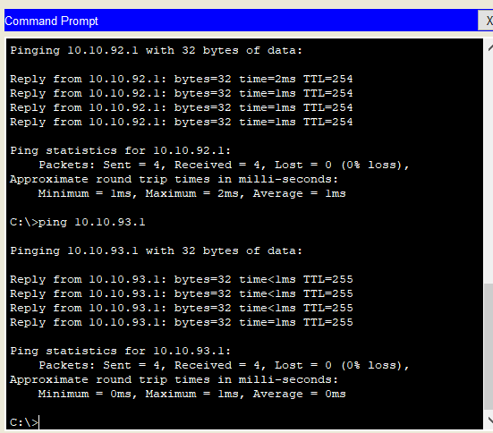

* 1. Some extra steps/worried moments
     1. When writing the dhcp pools I accidentally duplicated the one in corp2 to branch, but it turns out it was easy to fix by rewriting the command with the correct information.
     2. I also got worried after my addresses wouldn’t ping, turns out I had not done “end” on one of the routers so the settings were not actually implemented.

Conclusions and Discussion:

This chapter has helped me understand routing more clearly. In one of my other classes we have mentioned dropping packets when there isn’t a routing address, but this chapter has explained it more clearly. It seems like the other class is more of an overview of what is occurring, while this class is how you would actually set up; theory verses practice. I have come to realize from the readings just how little the packet changes where I thought it would be used the most, the routing layer. The main thing used in routing is the frame, which makes sense when I think about encapsulation and how one will want to dig through as little layers as possible to get access to the information one need’s (where it the packet going). I also find it really hard to believe that information travels one bit at a time; that is way too small. The 36 routing steps also clued me in on how a “simple” echo is actually fairly complicated or at least lengthy. This chapter was full of revelation for me, which has made me respect those who initially designed networking so much more.

The labs have been interesting. Static configuration is definitely a lot more work than I thought it would have been, but gladly dhcp is an easier solution. I am starting to understand why most routers have a default dhcp configuration. Every time I do these labs, I get curious about how much set-up a person installing a router at a resident’s house has to go through… maybe I will learn for myself one day!

Feedback:

NA- submitted day portfolio was due